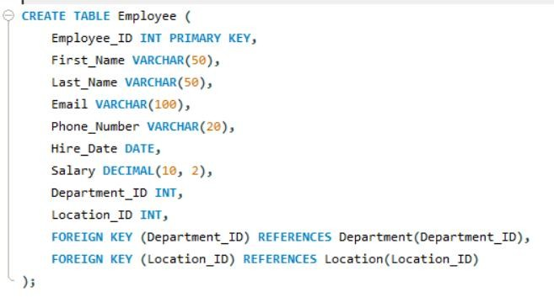

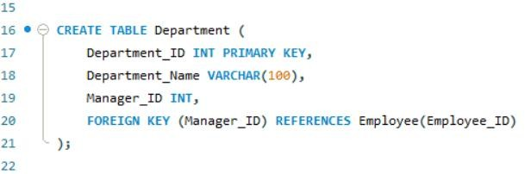

Department_IDis the primary key for this table.

Manager_IDis a foreign key referring to the Employee_IDfrom the Employeetable. This assumes that every department has one employee serving as the manager.

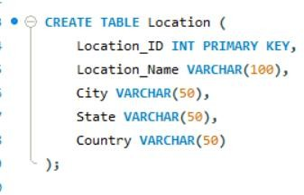

**Location_ID** is the primary key for this table.

The table contains attributes such as Location_Name, City, State, and Country, which define the location of a department.

The relational tables translate this ER model into SQL table definitions, with proper foreign key constraints to enforce the relationships between entities. This database structure will allow for efficient management and retrieval of employee, department, and location data while maintaining data integrity.